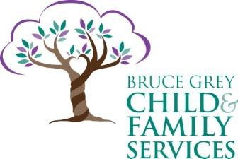INTEROFFICE MEMORANDUM

To: | All | From: | Kelly Ferris, Director of Corporate Service
cc: |  | Date: | December 31, 2019
RE: | Compliance with Broader Public Sector Accountability Act 2010  BGCFS 2018-2019 Annual Summary of Perquisites

It is BGCFS policy that no perquisites are allowed for employees and appointees. Total value of allowable perquisites incurred in 2018-2019 is: $NIL.
This memo represents compliance under the Broader Public Sector Perquisites Directive (August 2011). A copy of the memo will be posted to the organization’s website.

Any questions regarding the content can be directed to Kelly Ferris, Director of Corporate Service (519) 371-4453 ext. 4179.

